APPLICATION FOR CONSENT
Under Section 53 of the Planning Act

FILE #B………………

Note to Applicants: This application form is to be used if the CENTRAL ALMAGUIN PLANNING BOARD is the consent granting authority. In this form the term “subject” land means the land to be severed and the land to be retained.

Completeness of the Application

The information in this form that must be provided by the applicant is indicated by black arrows on the left side of the section numbers. This information is prescribed in the Schedule to Ontario Regulation 197/96 made under the Planning Act. The mandatory information must be provided with the appropriate fee. If the mandatory information and fee are not provided, the CAPB will return the application or refuse to further consider the application until the information and fee have been provided.

The application form also sets out other information that will assist the CAPB and others in their planning evaluation of the consent application. To ensure the quickest and most complete review, this information should be submitted at the time of application. In the absence of this information, it may not be possible to do a complete review within the legislated time frame for making a decision. As a result, the application may be refused.

Submission of the Application

- One application form is required for each parcel to be severed.
- A complete application form MUST include a council resolution from the organized municipality stating the pre-consult requirements have been met to its satisfaction and be accompanied by a list of conditions the municipality requires.

- The applicable fee is $675 per lot created, per Lot Addition or per Right of Way – effective January 1, 2017

- 10 copies of the completed application form and 10 copies of the sketch are required by the CAPB. The copies may be used to consult with other ministries or agencies that may have an interest in the application.

- Please remember to include your property roll number

Measurements are to be in metric units.
1 ft = .3048 meters; 1 acre = 0.404686 hectare

For Help

To help you understand the consent process and information needed to make a planning decision on the application, refer to the Guide.

You can also call:
Susan L. Arnold, Secretary - Treasurer
Central Almaguin Planning Board
63 Marie St, P. O. Box 310
South River, On POA 1X0 705 386 - 2573
e-mail: centralalmaguinplan@hotmail.com
Web Page for forms: www.strongtownship.com
Office hours: Wednesdays- 9:00 a.m. to 2:00 p.m.

- Please Print and Complete Appropriate Box(es)
1. | Application Information – MUNICIPAL TAX - ROLL #
 | 1.1 | Name of Owner(s). An owner’s authorization is required in Section 11.1, if the applicant is not the owner.
 |  | Name of Owner(s) | Home Telephone No. | Business Telephone No.
 |  | Address |  | Postal Code
 | 1.2 | Agent/Applicant: Name of the person who is to be contacted about the application, if different than the owner.  (This may be a person or firm acting on behalf of the owner.) e-mail -
 |  | Name of Contact Person/Agent | Home Telephone No. | Business Telephone No.
 |  | Address | Postal Code | Fax No.

2. | Location of the Subject Land (Complete applicable boxes in 2.1)
 | 2.1 | District | Local Municipality/Unorganized Township | Former Municipality | Section or Mining Location No.
 |  | Concession Number(s) | Lot Number(s) | Registered Plan No. | Lot(s)/Block(s)
 |  | Reference Plan No. | Part Number(s) | Municipal Address | Parcel Number
 | 2.2 | Are there any easements or restrictive covenants affecting the subject land?  - No Yes If Yes, describe the easement or covenant and its effect.
1101(08/96) Page 2

3. | Purpose of this Application
 | 3.1 | Type and purpose of proposed transaction (check appropriate box)  Transfer Creation of a new lot Addition to a lot An easement Other purpose  Other A charge A lease A correction of title
 | 3.2 | Name of person(s), if known, to whom land or interest in land is to be transferred, leased or charged
 | 3.3 | If a lot addition, identify the lands to which the parcel will be added.

4. | Description of Subject Land and Servicing Information (Complete each subsection.)
 | 4.1 | Description | Frontage (m.) | Severed | Retained
 |  |  | Depth (m.)
 |  |  | Area (ha.)
 | 4.2 | Use of Property | Existing Use(s)
 |  |  | Proposed Use(s)
 | 4.3 | Buildings or  Structures | Existing (Date of Construction)
 |  | Buildings or  Structures | Proposed
 | 4.4 | Access  (check appropriate  space) | Provincial Highway
 |  | Access  (check appropriate  space) | Municipal road, maintained all year
 |  |  | Municipal road, seasonally maintained
 |  |  | Other public road (e.g. LRB)
 |  |  | Right of way
 |  |  | Water Access (if so, describe below)
 |  |  | Describe in section 9.1, the parking and docking facilities to be used and the approximate distance of these facilities from the subject land and the nearest public road.
 | 4.5 | Water Supply | Publicly owned and operated  piped water system
Privately owned and operated
individual well
Privately owned and operated
communal well
 |  |  | Lake or other water body
 |  |  | Other means
 | 4.6 | Sewage  Disposal  (Check  appropriate  space) | Publicly owned and operated  sanitary sewage system
 |  | Sewage  Disposal  (Check  appropriate  space) | Privately owned and operated  individual septic tank¹
 |  | Sewage  Disposal  (Check  appropriate  space) | Privately owned and operated  communal septic system
 |  |  | Privy
 |  |  | Other means
(1) A certificate of approval from the North Bay Mattawa Conservation Authority submitted
with this application will facilitate the review.
 | 4.7 | Other Services  Check if the service is  available | Electricity
 |  | Other Services  Check if the service is  available | School Bussing
 |  | Other Services  Check if the service is  available | Garbage Collection
 | 4.8 | If access to the subject land is by private road, or right of way was indicated in section 4.4., indicate who owns the land or road, who is responsible for its maintenance and whether it is maintained seasonally or all year.
101(08/96) Page 2
5. | Land Use
 | 5.1 | What is the existing official plan designation(s), if any, of the subject land?
 | 5.2 | What is the zoning, if any, of the subject land? If the subject land is covered by a Minister=s zoning order, what is the regulation number?
 | 5.3 | Are any of the following uses or features on the subject land or within 500 metres of the subject land, unless otherwise specified.  Please check the appropriate boxes, if any apply.
 |  | Use or Feature | On the  Subject Land | Within 500 Metres of Subject  Land, unless otherwise specified  (indicate approximate distance)
 |  | An agricultural operation including livestock facility or stockyard
 |  | A landfill
 |  | A sewage treatment plant or waste stabilization plant
 |  | A provincially significant wetland (Class 1, 2 or 3 wetland)
 |  | A provincially significant wetland within 120 metres of the subject land | N/A
 |  | Flood plain
 |  | A rehabilitated mine site
 |  | A non-operating mine site within 1 kilometre of the subject land
 |  | An active mine site
 |  | An industrial or commercial use, and specify the use(s)
 |  | An active railway line
 |  | A municipal or federal airport
 |  | Utility corridors

6. | History of the Subject Land
 | 6.1 | Has the subject land ever been the subject of an application for approval of a plan of subdivision or consent under the Planning Act?  - No Yes Unknown If Yes and if Known, provide the Ministry=s application file number and the decision made on the application.
 | 6.2 | If this application is a re-submission of a previous consent application, describe how it has been changed from the original application
 | 6.3 | Has the subject land ever been the subject of an application for approval of a plan of subdivision or consent under the Planning Act?  - No Yes If Yes, provide for each parcel severed, the date of transfer, the name of the transferee and the land use.

7. | Current Applications
 | 7.1 | Is the subject land currently the subject of a proposed official plan or official plan amendment that has been submitted to the Minister for approval?  - No     Yes        Unknown If Yes and if Known, specify the Ministry file number and status of the application.
 | 7.2 | Is the subject land the subject of an application for a zoning by-law amendment, Minister’s zoning order amendment, minor variance, consent  or approval of a plan of subdivision?  - No       Yes          Unknown If Yes, and if Known, specify the appropriate file number and status of the application.
1101(08/96) Page 3
8. | Sketch (Use the attached Sketch Sheet) To help you prepare the sketch, refer to the attached Sample Sketch.
The application shall be accompanied by a sketch showing the following:
- the boundaries and dimensions of the subject land, the part that is to be severed and the part that is to be retained
- the boundaries and dimensions of any land owned by the owner of the subject land and that abuts the subject land the distance between the subject land and the nearest township lot line or landmark, such as a railway crossing or bridge
- the location of all land previously severed from the parcel originally acquired by the current owner of the subject land
- the approximate location of all natural and artificial features on the subject land and adjacent lands that in the opinion of the applicant may affect the application, such as buildings, railways, roads, watercourses, drainage ditches, river or stream banks, wetlands, wooded areas, wells and septic tanks
- the existing use(s) on adjacent lands
- the location, width and name of any roads within or abutting the subject land, indicating whether it is an unopened road allowance, a public travelled road, a private road or a right of way
- if access to the subject land is by water only, the location of the parking and boat docking facilities to be used
- the location and nature of any easement affecting the subject land

9. | Other Information
 | Is there any other information that you think may be useful to the CAPB or other agencies in reviewing this application? If so, explain below or attach on a separate page.

10. | Affidavit or Sworn Declaration
I, ________________________________________________ of the ___________________________________________

in the __________________________________ make oath and say (or solemnly declare) that the information contained in
this application is true and that the information contained in the documents that accompany this application is true.

Sworn (or declared) before me

at the __________________________________________

in the __________________________________________

this _______ day of ________________________ 2 ____

_______________________________________________ ________________________________________________
Commissioner of Oaths Applicant

1101(08/96) Page 4
11. | Authorizations
 | 11.1 | If the applicant is not the owner of the land that is the subject of this application, the written authorization of the owner that the applicant is authorized to make the application must be included with this form or the authorization set out below must be completed.  Authorization of Owner for Agent to Make the Application  I, ___________________________________________, am the owner of the land that is the subject of this application for a  consent and I authorize ________________________________________________ to make this application on my behalf.  ______________________________________ ___________________________________________________  Date Signature of Owner
 | 11.2 | If the applicant is not the owner of the land that is the subject of this application, complete the authorization of the owner concerning personal information set out below.  Authorization of Owner for Agent to Provide Personal Information  I, ________________________________________________________, am the owner of the land that is the subject of this  application for a consent and for the purposes of the Freedom of Information and Protection of Privacy Act, I authorize  __________________________________________________________ as my agent for this application, to provide any of my personal information that will be included in this application or collected during the processing of the application.  ______________________________________ ___________________________________________________  Date Signature of Owner

12. | Consent of the Owner
Complete the consent of the owner concerning personal information set out below.

Consent of the Owner to the Use and Disclosure of Personal Information

I, ___________________________________________, am the owner of the land that is the subject of this consent application and for the purposes of the Freedom of Information and Protection of Privacy Act, I authorize and consent to the use by or the disclosure to any person or public body of any personal information that is collected under the authority of the Planning Act for the purposes of processing this application.

_______________________________________ ______________________________________________________
Date Signature of Owner

The CAPB will assign a File Number for complete applications and this should be used in all communications.

Applicant’s Checklist: Have you remembered to attach:
- 10 copies of the completed application form?
- 10 copies of the sketch?
- 1 copies of the North Bay Mattawa Conservation
Authority comments regarding Septic system
- The required fee payable to the Central Almaguin Planning Board

Forward to: CENTRAL ALMAGUIN PLANNING BOARD, P.O.Box 310, South River, ON POA 1X0

101(08/96) Page 5
Sketch Sheet
Sketch Accompanying Application. (Please Use Metric Units)  (See Section 8) | Key Plan N    

1101(08/96) Page 6
Sample Sketch
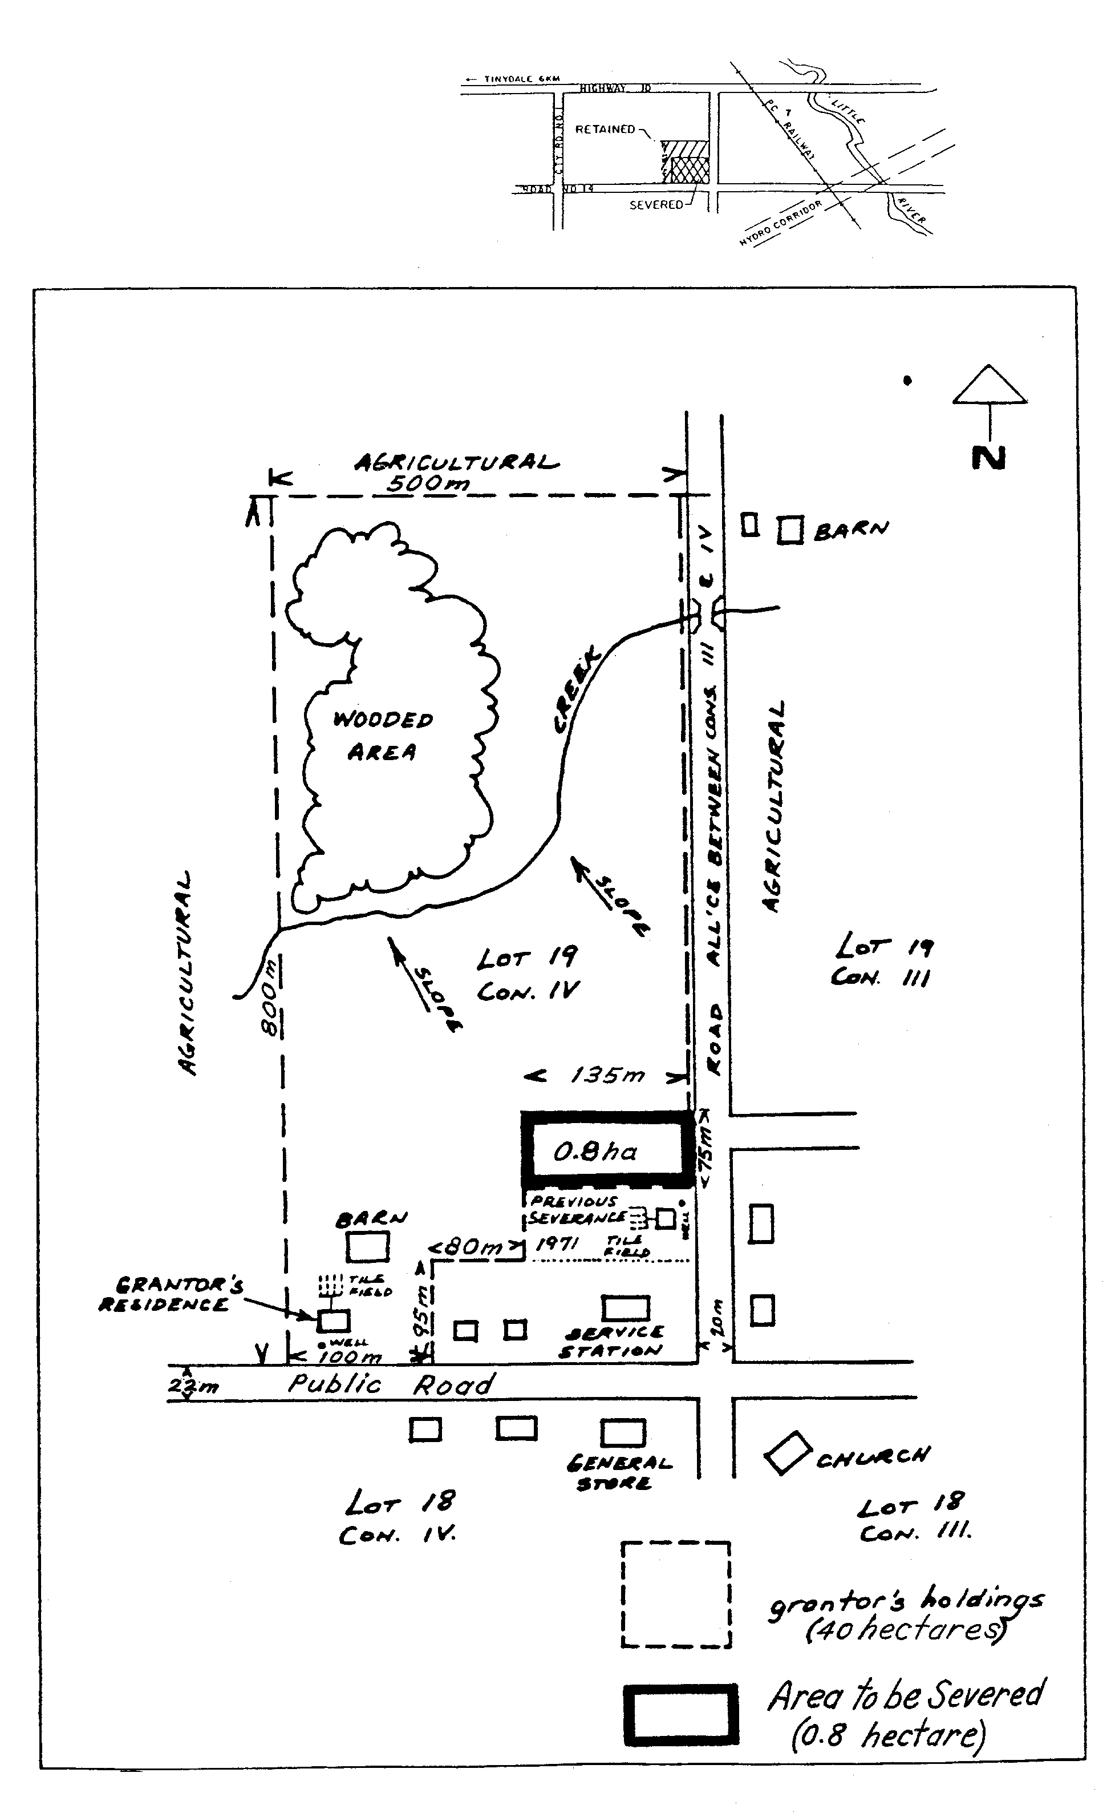
Please Use Metric Units  To Convert Multiply by To Find  Feet 0.3048 Metres  Acres 0.4046 Hectares | Key Map

1101(08

